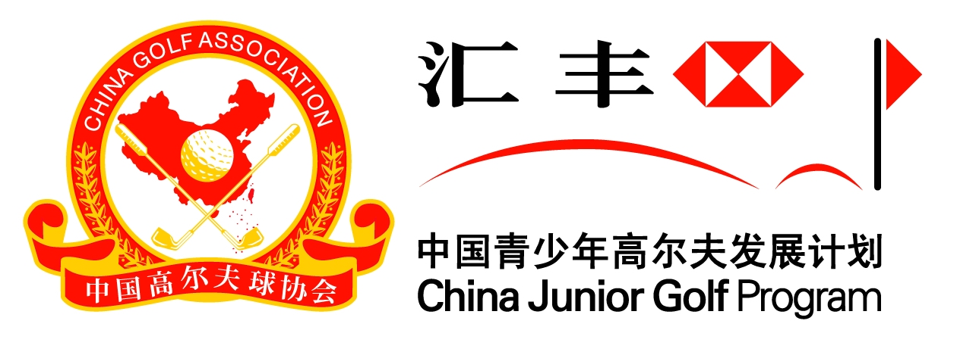

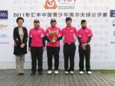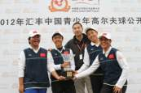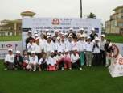

2014 HSBC China Junior Golf Open
Jan 7-10, 2014, Zhuhai, China

Sept 23, 2013
Dear Sirs / Madam,
2014 HSBC China Junior Golf Open Invitation
The 2014 HSBC China Junior Golf Open will be held from Jan 7-10, 2014 (Tuesday to Friday) in Zhuhai Golden Gulf Club,Guangdong China. Zhuhai Golden Gulf Club is the official golf course for China PGA Tour Qualifying School. This tournament is open to all junior golfers’ boys & girls aged from 11 to 17 (including 11 and 17-year-old) and we are expecting a strong competitive field of about 150 top level players from China and overseas. We would like to invite your country’s Top junior players to attend this Annual International Junior Golf Event in China. Each delegation is allowed a maximum of 4 players, two boys & two girls combined. Team score is based on the accumulation of daily team’s 3 best individual scores regardless of gender or age groups. As the Junior Open also awards trophy and prizes to individuals (handicap under 15) as well as team winners, we would also welcome other players from your country to attend our event as individual entrants and we also set up rankings and prizes.
Age Groups: Group A(15-17 year-old) Group B (13-14 Year-old) Group C(11-12 year-old)
Schedule: Jan 7, Practice round; Jan 8-10, competition rounds and awards ceremony
Format: 54-hole Stroke play
The HSBC China Junior Golf Open is held annually at the beginning of each year and is one of the biggest junior tournaments under the HSBC China Junior Golf Program - the only sanctioned Junior Golf Program in China. The event is counted into R&A’s WAGR ranking system.
Each delegation is also invited to send one delegate (captain) to the 2014 HSBC China Junior Golf Open. Accommodation will be provided to the team at official hotel. Each delegation will be offered with 3 rooms during the tournament week and all lunches and dinners for both captain and players will be covered during the tournament week. The organizer will also arrange local transportation and souvenir gifts for all the delegations. We hope our arrangements will enable you to fully enjoy your visit to China. Other individual players need to cover all the cost by themselves.
Entry Fee
Each Team: 600 USD per Team (4 Players, 150 USD per player) or RMB930 per player
Individual players: 100 USD per player or RMB 620 per player
Please assist in distributing this information and organize a team of junior players to compete in the 2014 HSBC China Junior Golf Open, representing your country. Please kindly submit your entries (see attachment) to the Email address: cherry.chen@img.com, (CC: lili.liu@img.com) or to the fax +86 21 54051833, before Friday, Nov 22, 2013. We will forward the terms and conditions of play and other related materials in due course.
For any inquiries, please don’t hesitate to contact:
Cherry Chen from IMG Email : Cherry.chen@img.com Phone: +86 21 24196026 Mobile : +86 137 9543 1261
We look forward to being host to your junior golfers in this Open tournament.
Yours Sincerely

HSBC China Junior Golf Open Committee
2014 HSBC China Junior Golf Open （Jan 07-10, 2014 Zhuhai）
Entry From

Player Information for Non-Chinese Nationality
Name ____________________ | Nationality ____________________ | 報名時務請提供電子檔照片email 至  garoc.tw@msa.hinet.net
Date of Birth___ / ___ / _____ | Gender _______________________
dd mm yy
ID Card or Passport number _________________________________
Phone ____________  Cell phone _____________ | Handicap __________  Attested by __________
Registration E-mail Address ____________________________________________

(Guardian) Information
Guardian__________________ | Name______________________
Phone________________ Cell phone_________________ |  | E-mail address______________

Competition time: January 07-10, 2014, Zhuhai Golden Gulf Club

Please choose category
□ Team Applicants： Entry Fee 150 USD per player
□ Individual Applicants: Entry Fee 100USD per player
Boy： □ 11-12 year-old □ 13-14 year-old □ 15-17 year-old
Girl： □ 11-12 year-old □ 13-14 year-old □ 15-17 year-old

I agree that my son/daughter participate in the 2013 HSBC CHINA Junior Golf Open Competition and abide by the competition disciplines. I agree the image of my son/daughter during the event to be used in promotions of this event.

Guardian Signature ：______________ Date：_____________

After filling in this form，please submit to the China Golf Association by both email and fax：
Email: cherry.chen@img.com Fax: 86 21 54051833
CC: lili.liu@img.com

Four-day Schedule

Date/time
Jan 06 | Registration for players arriving earlier
15:30 -17:00 | Players registration at the golf club –T-shirt and materials distribution. Parents please kindly make a note to the committee if players cannot make the practice round.
Jan 07 | Registration, practice round
08:00 – 09:00 | Players registration at the golf club –T-shirt and materials distribution. Parents please kindly make a note to the committee if players cannot make the practice round.
09:00 – 09:30 | Opening ceremony
09:30 – 16:30 | 18 holes Practice Round
16:30 – 17:00 | Players & parents meeting (e.g. Local rules introduction) (to be held at clubhouse)
18:30 – 20:30 | Welcome dinner (to be held at Clubhouse)
Jan 08 | First Day – Round One
07:15 – 07:30 | Players sign-in, each player should make sure they arrive at the starter area 10 minutes before their tee-time.
07:30 | Tee off
16:00 | End of Tournament – Round One
Jan 09 | Second day – Round Two
07:15 – 07:30 | Players sign-in, each player should make sure they arrive at the starter area 10 minutes before their tee-time.
16:00 | End of tournament – Second Round
16:30 | Shuttle Bus to Airport
Jan 10 | Third day – Final Round
07:45 – 08:00 | Players sign-in, each player should make sure they arrive at the starter area 10 minutes before their tee-time.
08:00 | Tee off
16:00 | End of tournament – Final Round
16:30 | Awarding Ceremony
17:30 | Shuttle Bus to Airport
Note: The Tournament Committee reserves the right to adjust the above schedule when necessary.

HSBC China Junior Golf Program – 2007-2015

CGA-HSBC China Junior Golf Program, launched by the China Golf Association (CGA) and HSBC in coordination with IMG in early 2007, is the only officially sanctioned junior golf program in China.With the very successful outcome from past 6 years, on June 3rd, CGA and HSBC confirmed to continue this program for another 3 years (2013-2105). The program is designed to provide a competition platform for future champions, as well as a platform for grass-root kids to get to know what golf is.
The program has the strongest sponsor support from HSBC and is supervised by a development committee that is formed by representatives from HSBC, CGA, IMG and R&A. It not only provides a platform for talented joiner golfers to develop their potential, but also developed a lot of new blood for golf in China.
The comprehensive program includes the HSBC National Junior Golf Championship (6 stops+1 final), the HSBC National Team Championship, the HSBC China Junior Golf Open, a series of HSBC Junior Golf Camps at cities across China during summer and winter season, the HSBC sponsored China National Junior Team, the HSBC National School Training program, an HSBC Junior Golf Ranking System and an official website. This is a systematic and sustainable plan that is designed to support the grassroots development of Chinese golf on a long term basis. The winners of the HSBC National Junior Golf Championship Final or HSBC China Junior Open and Top ones from the ranking system will have a chance to be invited to play with golf Top pros in the HSBC Champions pro-am, HSBC Women’ s Champions pro-am and some other pro events.

The HSBC Junior Golf Ranking System, launched on Mar, 2008, covers not only events under the CGA-HSBC China Junior Golf Program but also other events sanctioned by the CGA. This ranking system forms a base for evaluation and selection of members for HSBC National Junior Golf Team.

HSBC Junior Golf Camps has entry-level camps and advanced camps which are designed for 0 level kids and national junior team or top players respectively during summer and winter holiday. The camps have introduced golf to more than 4000 kids and provide them a chance to swing and put on site each year. The advanced camps provides systematic training courses on physical skills, on course skills, rules, strategies etc to help the top players develop their potentials to be a pro from all around.

Starting from early 2008, CGA-HSBC China Junior Golf Program has launched its schools golf training project in nearly 100 schools in Shanghai, Beijing, Jiangsu, Anhui, Shenzhen, Zhejiang, Shangdong, Zhengzhou, Guangzhou, Hainan and Yunnan province, setting up golf fundamental education during Physical Education (PE) classes in schools. This project is intended to introduce golf to more kids as a sport and provide them with a chance to play, understand and love golf.
In Sept of 2008, the official website (www.golf.org.cn/youth) of CGA-HSBC China Junior Golf Program was launched, providing a more interactive information platform for juniors.
In March of 2009, the HSBC sponsored China National Junior Team has been formed to cultivate more elite junior players. The program will provide training sessions and competition opportunities to the team players. The team competed in 2012 Junior Open, 2012 Evian Masters Juniors Cup, 2012 RiverWoods Junior Open and 2012 USA-China Youth Match (team China won) during summer holidays.

