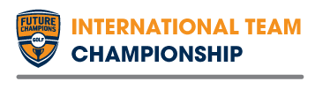  2014 FCG International  Team Championship Information  A Competition within a Competition at the FCG International Junior Golf Championship  July 7-9, 2014 | 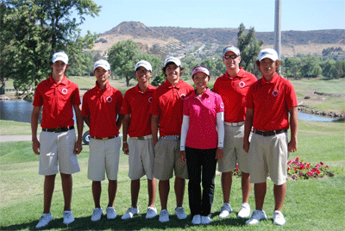

- Teams will be comprised of 2 Boys and 2 Girls in the 15-18 category and scores will count for round 1 and round 2 of the FCG International Individual Stroke Play Championship
- Any country, academy, association can field a Team (space is limited) and you can form multiple teams per organization (ex. Hong Kong National Team A and B) Max of 4 Teams.
  - Note – All players must be individually registered for the FCG International Junior Golf Championship. Players register at http://www.futurechampionsgolf.com/jrmasters.html
- All teams must be finalized and emailed Team Name and Roster to antrone@futurechampionsgolf.com
by June 15, 2014 at the latest.
- Team Format
  - 36-Hole Team Stroke Play counting all 4 Players scores each day
- Team Photos
  - Your Team must take a Group Photo with our Photographer immediately following Round 1
- Winning Team
  - Featured on FCG International Junior Golf Championship website as the TEAM CHAMPIONS
  - Medals for Our Champions and Team Name added to the Perpetual Trophy
- Past Champions
    - http://www.futurechampionsgolf.com/jmteamchampionship.html

