Aaron Baddeley
International Junior Championship
December 5th – 10th

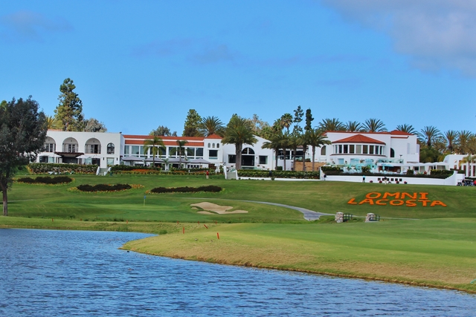
Omni La Costa Resort and Spa
(http://www.omnihotels.com/hotels/san-diego-la-costa)
2100 Costa Del Mar Rd, Carlsbad, CA 92009

Team Player – US$1,995.00 per person - Double Occupancy (paired with another junior)
- Tournament entry including two practice rounds, four rounds of competition, and tee gifts
- Daily access to the resort driving range and practice facility
- Six nights stay in a twin share room (December 4-10, or December 5-11, extended stay available upon request for additional charge)
- Breakfast buffet each morning
- Meal voucher for the Dec. 6th Welcome Dinner and Dec. 7th College Golf Seminar

Individual Competitors – US$2,195.00 per person - Double Occupancy (paired with another junior)
- Tournament entry including two practice rounds, four rounds of competition, and tee gifts
- Daily access to the resort driving range and practice facility
2/
2

- Six nights stay in a twin share room (December 4-10, or December 5-11, extended stay available upon request for additional charge)
- Breakfast buffet each morning
- Meal voucher for the Dec. 6th Welcome Dinner and Dec. 7th College Golf Seminar

Parent/Guest Package – US$1,650.00 per person - Single Occupancy
- Six nights stay (December 4-10, or December 5-11, extended stay available upon request for additional charge)
- Breakfast buffet each morning
- Ticket for the Dec. 6th Welcome Dinner and Dec. 7th College Golf Seminar

Individual Competitor with their Parent - US$2,995.00 - total for both.
- Tournament entry including two practice rounds, four rounds of competition, tee gifts
- Daily access to the resort driving range and practice facility for the competitor
- Six nights stay in a twin share room (December 4-10, or December 5-11, extended stay available upon request for additional charge)
- Breakfast buffet each morning for each the competitor and parent
- Ticket for the Dec. 6th Welcome Dinner and Dec. 7th College Golf Seminar for each the competitor and the parent

Parent/Guest Package - US$1,995.00 Double Occupancy – total for both.
- Six nights stay (December 4-10, or December 5-11, extended stay available upon request for additional charge)
- Breakfast buffet each morning
- Ticket for the Dec. 6th Welcome Dinner and Dec. 7th College Golf Seminar

Team Manager - US$995.00 per person - Single Occupancy
- Six nights stay (December 4-10, or December 5-11, extended stay available upon request for additional charge)
- Breakfast buffet each morning
- Ticket for the Dec. 6th Welcome Dinner and Dec. 7th College Golf Seminar

2nd Team Manager - Double Occupancy – US$1,995.00 - total for both.
- Six nights stay (December 4-10, or December 5-11, extended stay available upon request for additional charge)
- Breakfast buffet each morning
- Ticket for the Dec. 6th Welcome Dinner and Dec. 7th College Golf Seminar

2nd Team Manager - Single Occupancy – per person - US$1,655.00
- Six nights stay (December 4-10, or December 5-11, extended stay available upon request for additional charge)
- Breakfast buffet each morning
- Ticket for the Dec. 6th Welcome Dinner and Dec. 7th College Golf Seminar

