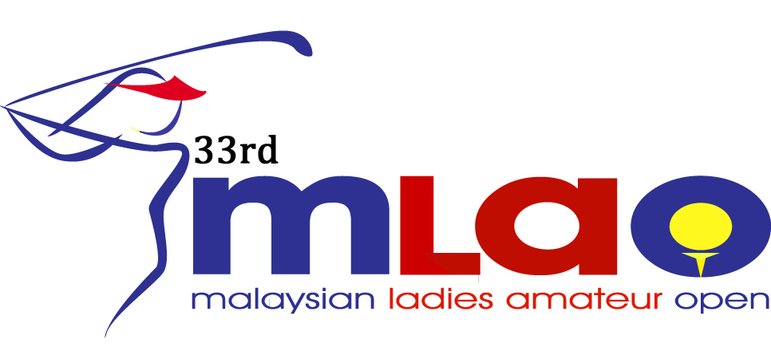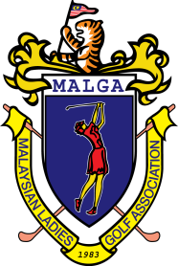

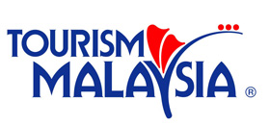

Resort World Genting Awana Golf & Country Resort
August 17 – 19, 2016
CLOSING DATE : July 15, 2016

GENERAL INFORMATION

- ENTRY FEE : MALGA Member RM 750 per player
Foreign Participation & Others USD 350 per player
Team Event RM 150 per team

- OFFICIAL HOTEL : Resort World Genting Awana Hotel
KM 13, Genting Highland Resort,
69000 Pahang Darul Makmur
Malaysia
Tel : 60 (3) -6436 9000 Ext : 53010
Fax : 60 (3) -6101 1133
Email : customercare@rwgenting.com

Superior Room including breakfast : Single or Twin: RM 195 per room per night

- TRANSPORTATION : Airport Transfer from Kuala Lumpur International Airport to Resort World Genting Awana Hotel
(estimated 1.5 hours)
Rates RM 400 per van Van per way maximum 4 players including golf bags + luggage.
Please email to malga@malga.org.my on your requirements.

- MEALS : Lunch will be provided for players during the three (3) competition days.

- CADDY TIPS : RM 50 per caddy / 18 holes (twin sharing)

- Bank Details : Payble to : MALAYSIAN LADIES GOLF ASSOCIATION
Name Of Bank : Malayan Banking Berhad
Bank Address : Wisma Hangsam Branch, No 1, Jalan Hang Lekir
50000 Kuala Lumpur, Malaysia
Account No : 5140 3923 4279
Int. Swift Code : MBBEMYKL

DATE | TIME | ACTIVITIES
16th August (Tue) | 0630 - 1600  0730 - 1300  1600  1630 | Registration at Tournament Office @ Awana Hotel  Practice round  Course closed.  Welcome Hi-Tea @ Kenari Pool Side  Photo session of players by country.
17th August (Wed) | 0730 - 0930  1100 - 1500 | 1st Round– 2 tee start  Lunch @ Kenyalang
18th August ( Thurs) | 0730 - 0930  1100 - 1500 | 2nd Round – 2 tee start.  Lunch @ Kenyalang
19th August (Fri) | 0730 - 0930  1300 - 1330  1400 - 1500 | 3rd Round – 2 tee start.  Trophy Presentation @ practice green  Prize Presentation Lunch @ Dewan Wawasan
TOURNAMENT SCHEDULE

