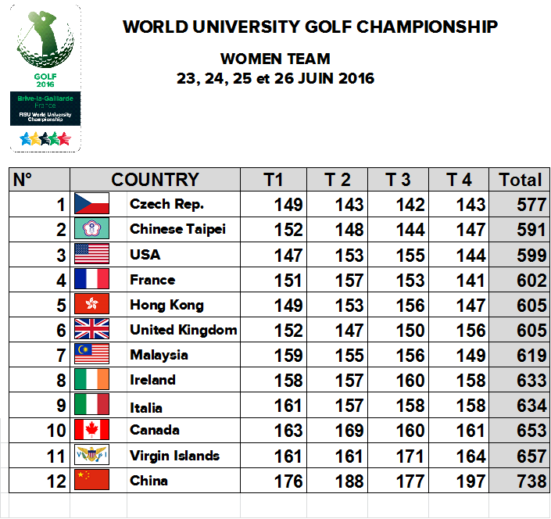

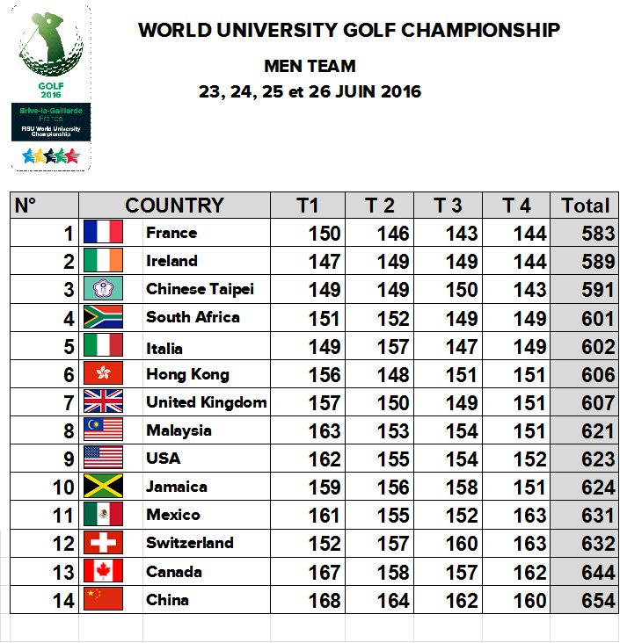

[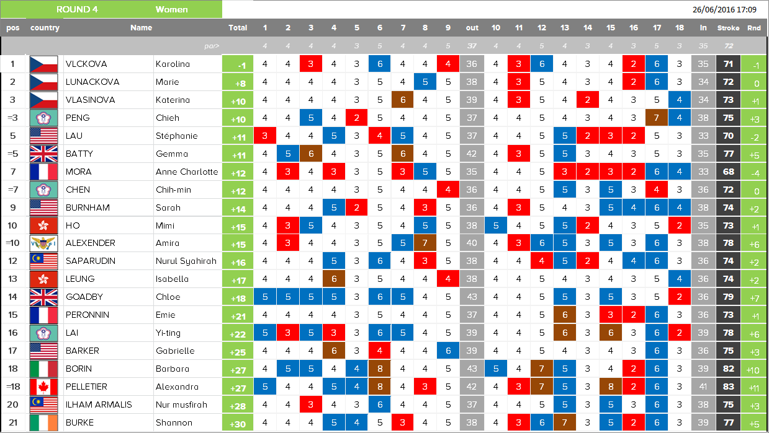](http://wuc-golf2016.com/en/livewp1-4/)

[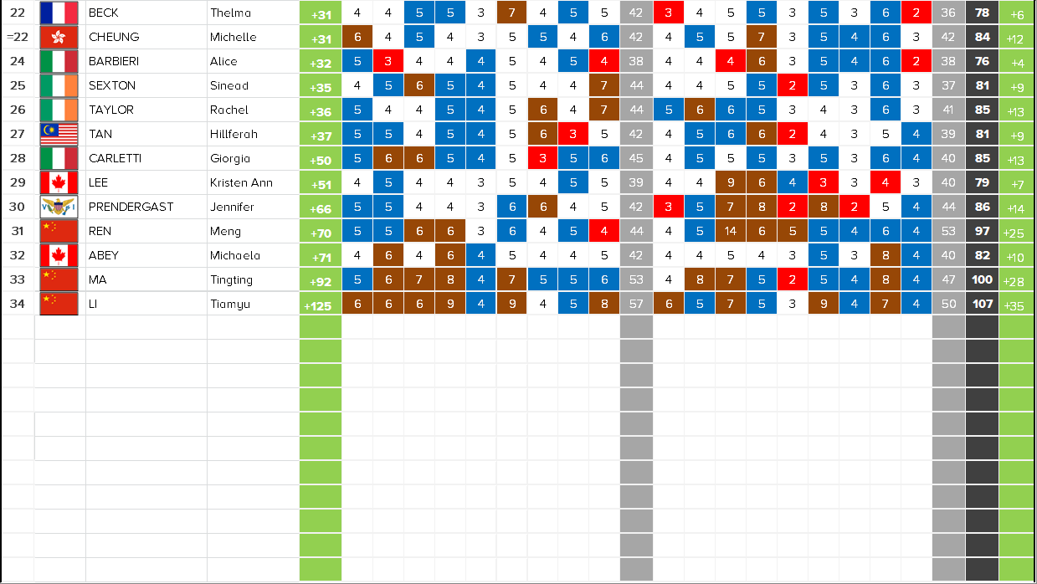](http://wuc-golf2016.com/en/livewp2-4/)

### [LIVEMP1](http://wuc-golf2016.com/en/livemp1-4/)

[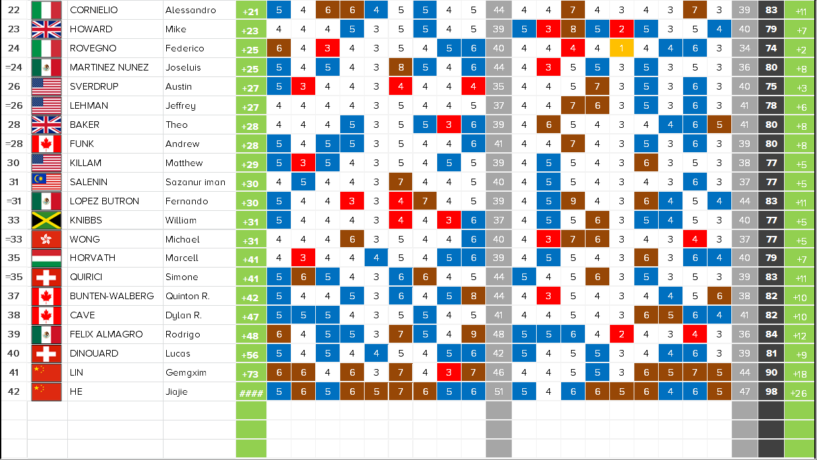](http://wuc-golf2016.com/en/livemp2-4/)