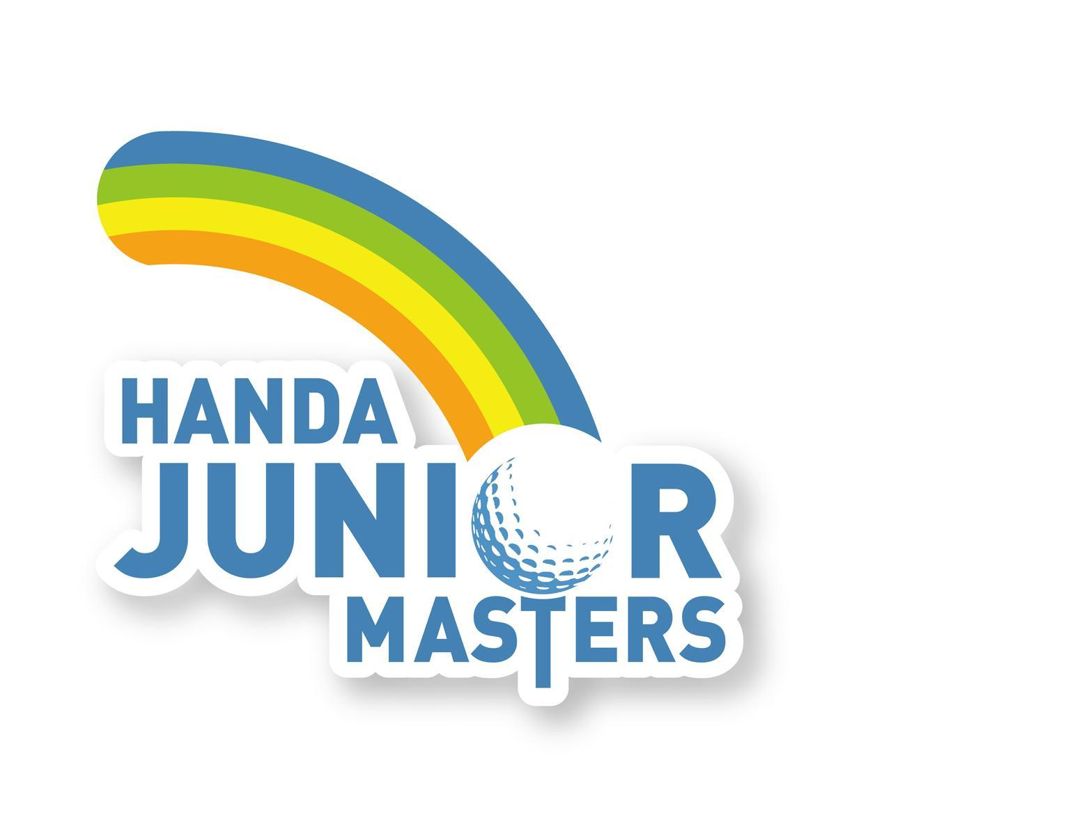

Ms Heidi Sheng
Chinese Taipei Golf Association
12th Floor Nanking East Road Sec 2
TAIPEI 104
TAIWAN

18 January 2010

Dear Heidi

It is with great pleasure that we extend an invitation to the Chinese Taipei Golf Association to send representatives
to compete in the 2010 Handa Junior Masters being hosted by The Vines Resort and Country Club from Tuesday 11 May
to Friday 14 May 2010. 我們很榮幸邀請中華台北高協派員參加2010年Handa青少年名人賽，比賽將於5月
11(週二)至14日(週五)在樹藤休閒鄉村俱樂部舉行。

This invitation is for you to nominate one leading Junior boy and one leading Junior girl to compete.
請提名最佳一男一女選手參賽。

The following information details the tournament set up.詳細比賽資訊如下

1.

2.

3.

4.

5.

Age Limit 年齡限制
Under eighteen as at 1 January 2010. 在2010年1月1日時仍未滿18歲

Travel 行程
When arranging travel for your competitors, please ensure that players arrive NO EARLIER than
Sunday 9 May 2010 (afternoon) and return NO LATER THAN Saturday 15 May 2010 (morning).
安排貴國選手行程時，務請抵達時間勿早於5月9日(週日)下午，返國勿晚於5月15日(週六)早上。

Accommodation 住宿
Accommodation will be provided for all of your nominated players. Male and female
chaperones will be on hand throughout the week to look after your players or you are
welcome to send a representative from the Association.
Players will be hosted in a villa at The Vines Resort with a maximum capacity of 4 guests.
將提供所有提名選手住宿，整週會安排男女監護人就近照顧選手，也歡迎您自派領隊。
選手將住宿在球場別墅，最多四人一間房。

Transfers 交通
Transfers to and from Perth Airport will be provided free of charge. Please ensure you
notify the tournament office as soon as travel has been arranged so transfers can be organised.

Notification can be made by phoning +61 8 9380 6978 or via email to gemma.liddelow@vaultsm.com.
提供伯斯機場免費接送。行程安排好請務必儘早告知大會，以便安排接機。
可致電 +61 8 9380 6978或email至 gemma.liddelow@vaultsm.com

Meals 餐飲
All meals (breakfast, lunch and dinner) will be provided for your players. A charge of
$145 per player AND chaperone will cover all accommodation and meals expenses at
The Vines Resort.

6.

7.

8.

9.

Meals commence with dinner on Sunday 9 May through to breakfast on Saturday 15 May.
Please notify the tournament office if you require special meals (eg: vegetarian or particular allergies).
提供選手和監護人早、午、晚餐，含在澳幣145元膳宿費內，從5月9日(週日)晚餐開始
至5月15日(週六)早餐。如需特殊餐飲(例如素食或食物過敏)請告知大會。

Entry Fees 報名費
An entry fee of $55.00 is applicable for all entrants in the tournament. All players will receive tournament merchandise upon registration including caps, shirts and other goods. 每位澳幣55元，選手將於報到時領取比賽
紀念品，包括帽子、上衣、和其他物品。

Practice Balls 練習球
These will be provided free of charge from Monday 10 May – Friday 14 May 2010.
Those wishing to hit balls on Sunday 9 May after arrival will be required to purchase their own practice balls.
5月10~14日提供免費練習球。5月9日抵達後欲練習者需自行購買練習球。

Field Size 參賽人數
The field size will be limited to one hundred invitation only players. 限制在100位受邀選手

Boys and girls from each State and Foundation will be invited to participate together with invited players
from New Zealand, South Africa, Korea, Thailand, Malaysia, Singapore, Philippines, Taiwan, Hong Kong,
China, United Arab Emirates, Indonesia, India and the Netherlands. 包括澳洲國內、紐西蘭、南非、韓國、
泰國、馬來西亞、新加坡、菲律賓、台灣、香港、中國、阿拉伯聯合大公國、印尼、印度，荷蘭的
男女選手。

General Event Information 一般賽事資訊

9.1 The Handa Junior Masters will be played over seventy-two holes of stroke play 72洞比桿賽

Round One 第一回合 Tuesday 11 May 5月11日(週二)
Round Two 第二回合 Wednesday 12 May 5月12日(週三)
Round Three 第三回合 Thursday 13 May 5月13日(週四)
Round Four 第四回合 Friday 14 May 5月14日(週五)

Note: A seeded draw will be used for Rounds Three and Four. 註：第三、第四回合依成績編組

9.2 Practice 練習
Practice will be on Sunday 9 May (afternoon) and Monday 10 May (morning).
Practice times must be booked with Tournament Organisers before the event or at registration.
Please phone the tournament office on +61 8 9380 6978 or email gemma.liddelow@vaultsm.com
(prior to Sunday 9 May 2010) to secure a practice tee time. 5月9日(週日)下午和5月10日(週一)早上
開放練習。練習時間必須於賽前或報到時向大會預訂。請於5月9日(周日)前致電大會
+61 8 9380 6978或Email至gemma.liddelow@vaultsm.com預約開球時間。

9.3 Junior-Am 配對賽
A Junior-Am (Sponsors Day) will be held on Monday 10 May 2010. A number of players will be
invited to participate in the Junior-Am playing in teams of 4 with our valued sponsors. Selection
for the Junior-Am will be done by tournament organisers who endeavor to include as many juniors
as possible in the day.
Being selected to play in the Junior-Am is a privilege and players are required to play unless
they can provide Tournament Organisers with a valid reason why they cannot well prior to Sunday 9 May.
配對賽(贊助商日)為5月10日(週一)。一些選手將受邀與贊助商同組比賽，每組四人，由大會挑選
選手，儘可能安排最多人數參加。被選為參加配對賽是項殊榮，選手必須參加，除非能在5月9日
(週日)前向大會提出正當理由說明為何不能參加。

9.4 The leading boy will receive an exemption to play in the 2010 Australian Open.
The leading girl will receive an exemption to play in the ANZ Ladies Masters in
February 2011.

9.5

男子冠軍將獲邀參加2010年澳洲公開賽
女子冠軍將獲邀參加2011年2月的ANZ女子名人賽
Trophies will be awarded on a daily and overall basis to the leading players –
both boys and girls. 將頒發男、女每日冠軍獎及總冠軍獎盃

Please visit www.vaultsm.com and follow the links to the 2010 Handa Junior Masters for
full tournament information and updates. Entries must be received by Friday 16 April 2010.

Entries must be returned to: 請上網查詢比賽資訊 www.vaultsm.com，報名表必須於4月16日前寄至：

Vault Sports Management
PO Box 8208
SUBIACO EAST WA 6008
AUSTRALIA

or via email to gemma.liddelow@vaultsm.com.

Should you have any queries please do not hesitate to contact the tournament office at Vault Sports Management
on +61 8 9380 6978 or via email to gemma.liddelow@vaultsm.com.
如有任何問題請電 +61 8 9380 6978或email至 gemma.liddelow@vaultsm.com。

We look forward to seeing all your competitors at the 2010 Handa Junior Masters.
我們期待您的選手前來參賽

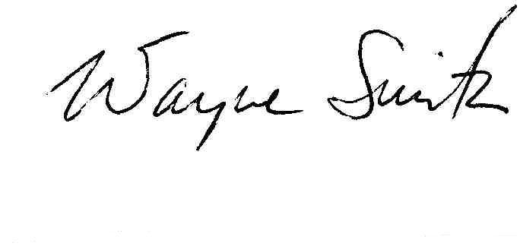
Yours sincerely

Wayne Smith
Tournament Chairman
Handa Junior Masters
Handa青少年名人賽 賽事主席 偉恩•史密斯

