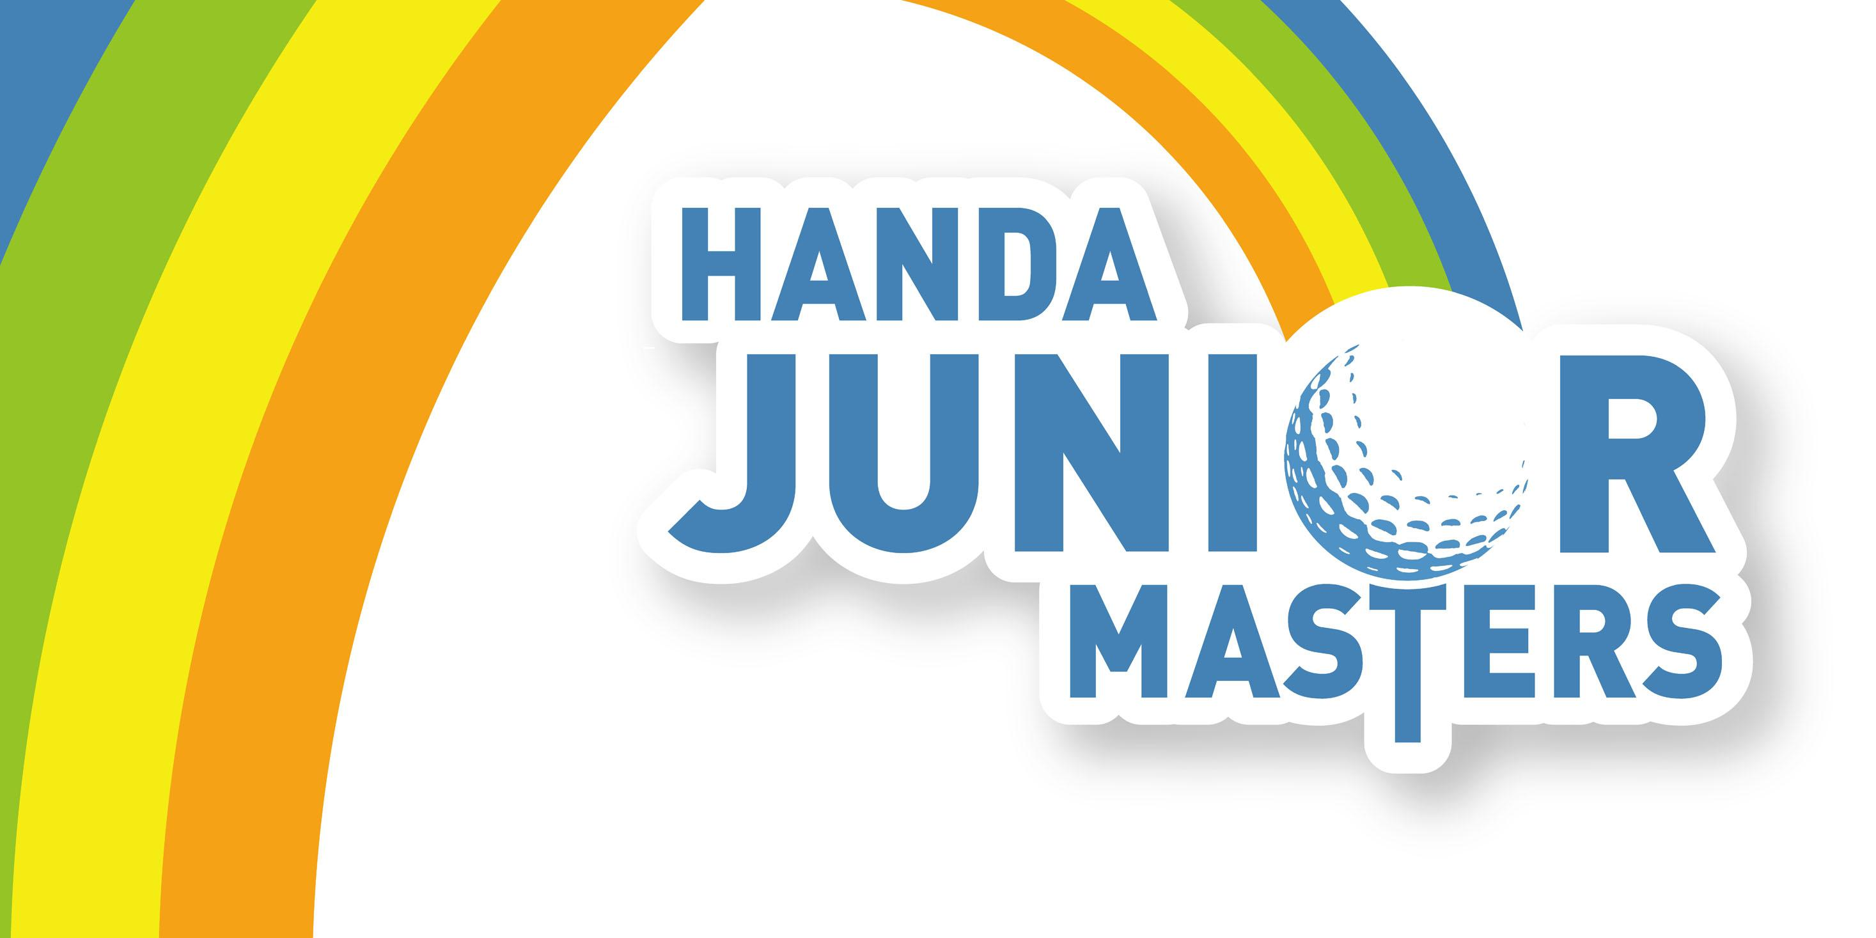

2010 Handa
Junior Masters

醫療授權書
AUTHORITY FOR MEDICAL TREATMENT

___________________________________________________________________
姓名
(Junior Competitors FULL NAME)

I, the undersigned authorise Vault Sports Management, or its nominated representative, to make such
arrangements as are deemed necessary by the attending medical practioner in the event of
emergency medical treatment being necessary in respect of my son / daughter. 我授權主辦單位給予我子女必要的緊急醫療

Listed below are the specific medical care needs of my son / daughter including allergies and health
related issues organisers should be aware of: 下面是我子女所需要的一些特殊醫療照護，包括過敏等。

1.____________________________________________________________

2.____________________________________________________________

3.____________________________________________________________

4.____________________________________________________________

Emergency Contact Numbers 緊急聯絡電話

Name of Contact: 聯絡人姓名___________________________________________________________________

Day time: 白天聯絡電話____________________________ After Hours: 晚上聯絡電話__________________________

Medical Authorisation 醫療授權

Parent or Guardians Name: 父母或監護人姓名_____________________________________________________

Signature of Parent or Guardian: 父母或監護人簽字___________________________________

Date 日期________________

FORM MUST BE COMPLETED IN FULL AND SUBMITTED WITH OFFICIAL ENTRY

PO Box 8208 SUBIACO EAST WA 60081
Phone: +61 8 9380 6978
Fax: +61 8 9264 8295

