

December 14, 2010

Dear Friends,
Junior Golf
Foundation
of the Philippines

The Junior Golf Foundation of the Philippines is pleased to announce The Montecillo Junior Golf Team
Championship in honour of the Asia Pacific Junior Golf Confederation (APJGC) and JGFP founder Mrs.
Amalia “Maling” Montecillo. The event is sanctioned by the National Golf Association of the Philippines
(NGAP) and is scheduled on March 8-11, 2011 which will be held at the prestigious Mount Malarayat Golf
and Country Club in Lipa City, Batangas.
菲律賓青少年高爾夫基金會很高興宣佈將舉辦Montecillo青少年高爾夫隊際錦標賽，此乃為紀念
已過世的亞太青少年高爾夫協會 (亞青) 暨菲律賓青少年高爾夫基金會創辦人Montecillo女士。比賽為
菲律賓高協核准之賽事，將於2011年3月8-11日在呂宋島南部黎巴城著名的馬拉若亞山高爾夫鄉村
俱樂部舉行。

The Organizing Committee would like to invite your best junior golfers composed of 4 boys and 3 girls who
have not reached 19 years of age on the last day of the Championship (March 11, 2011). Entry fee is
US$100 per player. 主辦單位欲邀請貴國最佳的四男三女，在2011年3月11日未滿19歲的選手參加。
報名費每人100美金。

We will provide the following for your 7 nominated players & 1 official: 我們將提供七位提名選手和一位
領隊下列招待：

 FREE 6 nights hotel accommodations at the official hotel (2 Rooms)
六晚免費住宿 (兩個房間)
 Local transportation between airport-hotel and hotel-airport. 接送機
 Breakfast during the tournament proper 比賽期間的早餐
 Souvenir items & giveaways 紀念品

We would appreciate if you could send us your intent of participation on or before January 15, 2011.
Complete details of the event will be sent via email within this month and will also be posted on our website
soon. 請於2011年1月15日前回覆參賽意願。詳細資料將於本月以email寄出。

Should you have any queries, please feel free to email us at admin@jgfp.com.ph or
jungolf1976@yahoo.com. 如有任何問題請和我們連絡

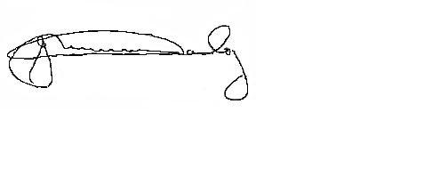
Thank you very much and we look forward to hearing from you soon. 謝謝您並希望您儘早回覆。

Yours sincerely,
GERARDO M. HANDOG
Chairman
Junior Golf Foundation of the Philippines and
The Montecillo Junior Golf Team Championship Organizing Committee

Junior Golf Foundation of the Philippines, 3rd Floor Makati Golf Club, 7232, Malugay St., Bel Air, Makati 1209, Metro Manila, Philippines
Telephone: +632 893 9599 Fax: +6328939499 Email: jungolf1976@yahoo.com
Developing Golf’s Future

