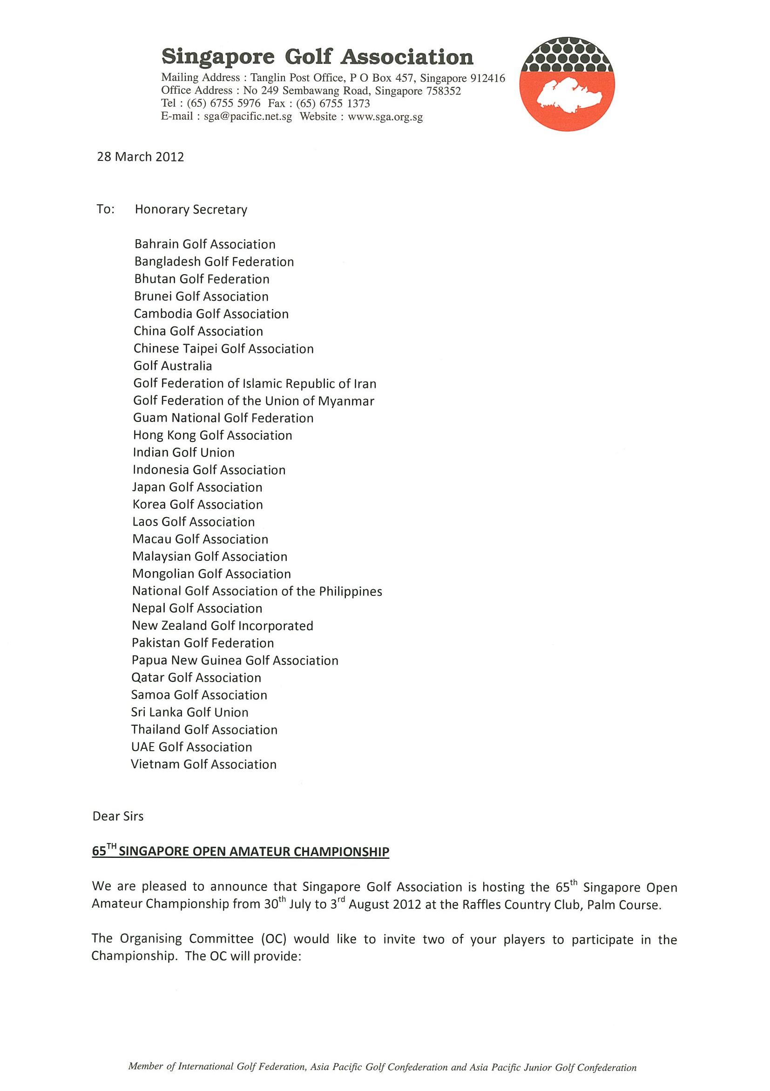
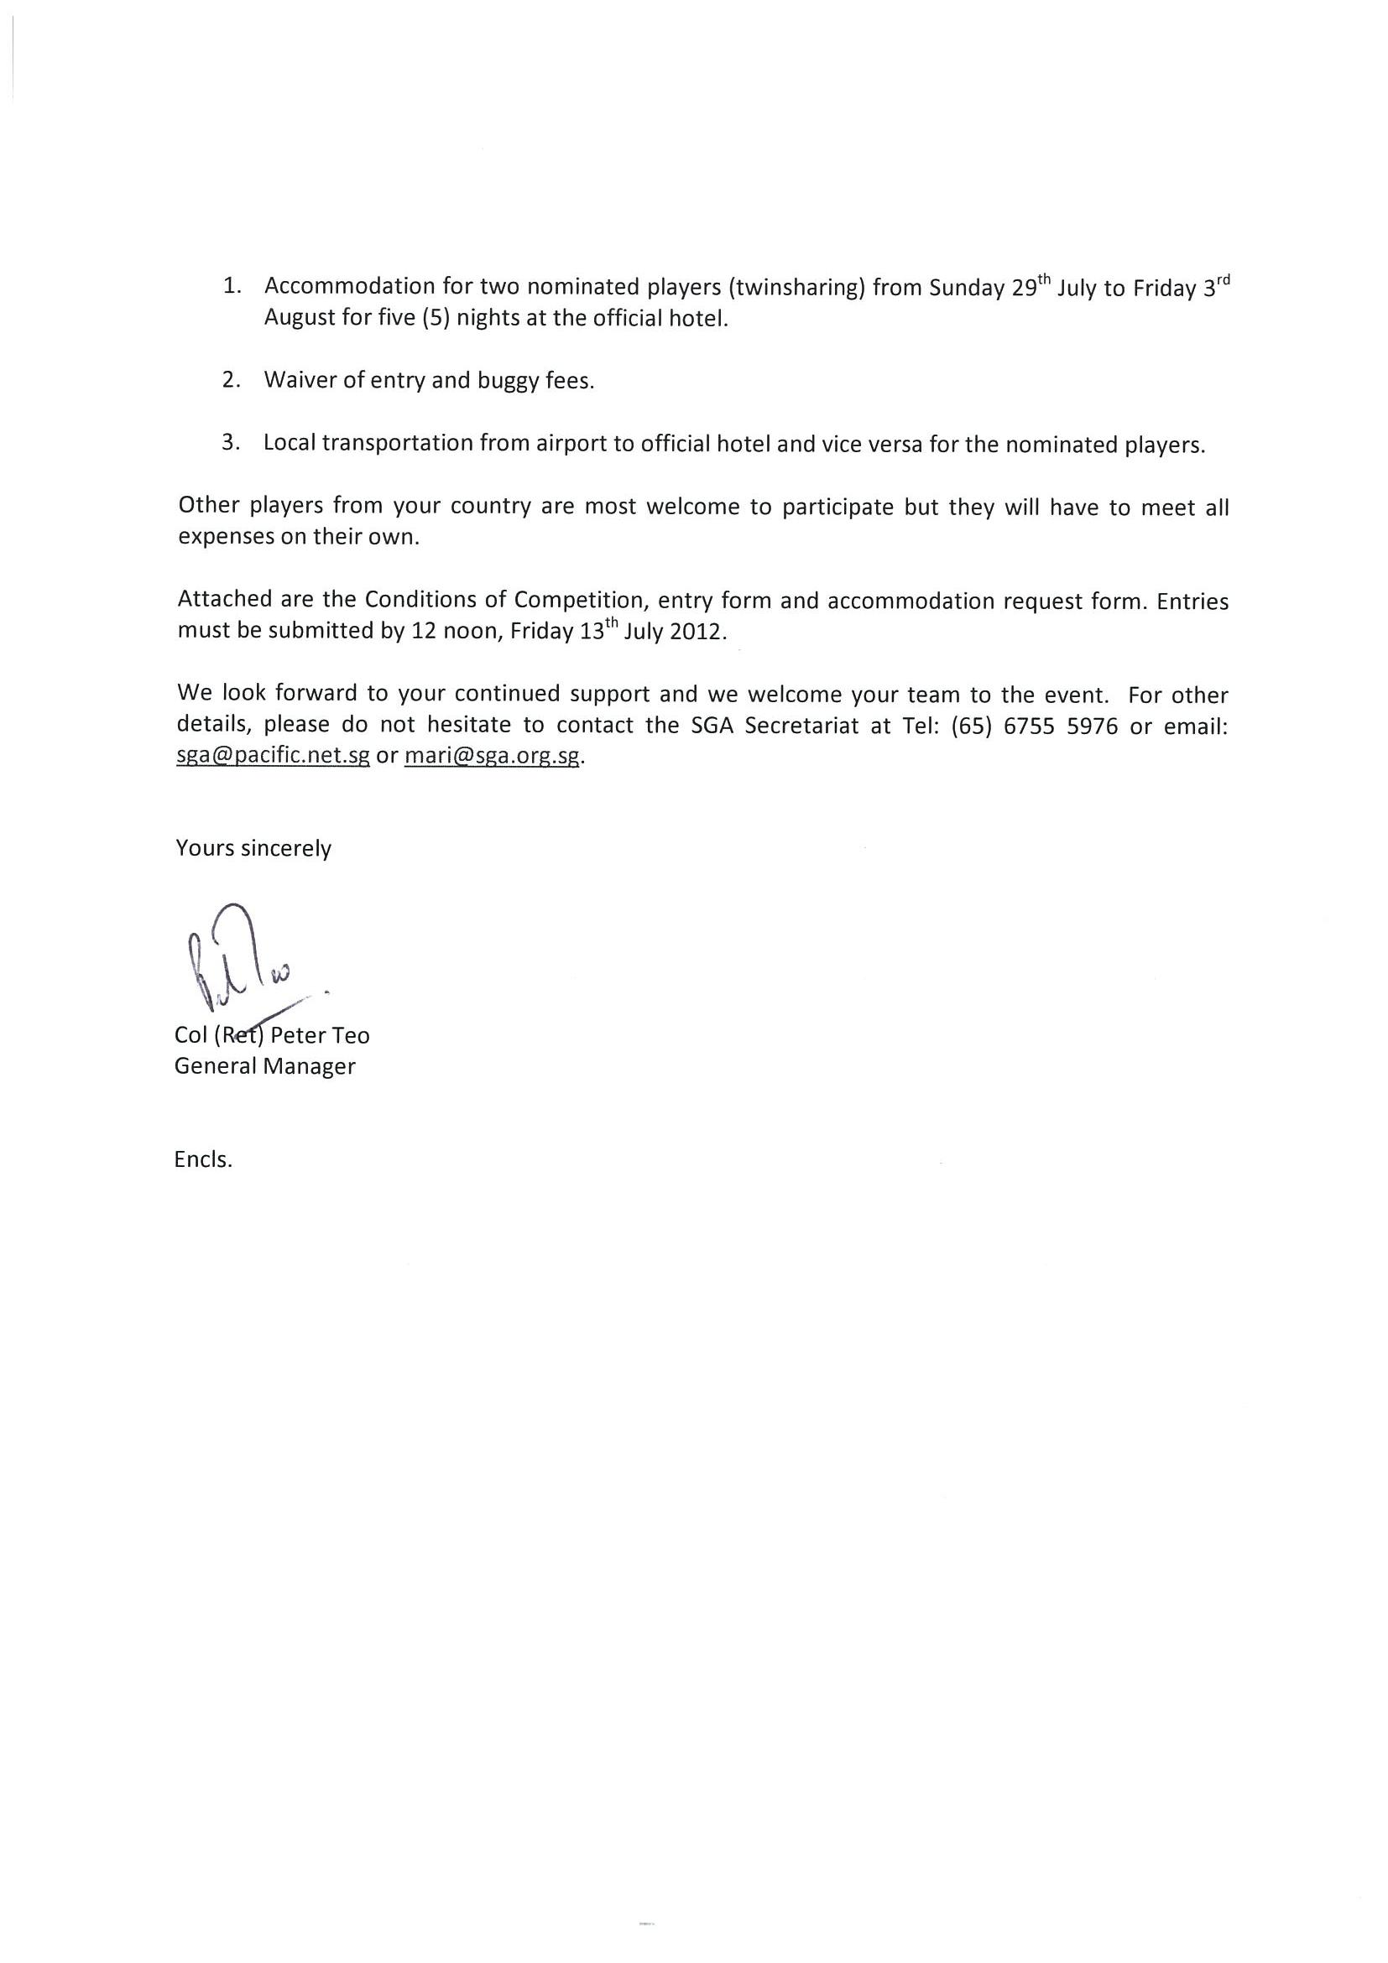
第65屆新加坡業餘公開錦標賽
邀請函

我們很高興宣佈新加坡高協將於2012年7月31日至8月3日在萊佛士鄉村俱樂部棕櫚球場舉行第65屆新加坡業餘公開錦標賽。

主辦單位欲邀請貴國提名2位選手參加，並提供下列的招待：
1. 指定飯店五晚的雙人房住宿 – 7月29日至8月3日
2. 免付報名費和球車費
3. 機場至指定飯店的接送

我們亦歡迎其他選手參加但所有費用須自理。

附件是比賽條件、報名表，和住宿申請表。請於7月13日中午
12:00前繳交。

期盼您繼續支持並歡迎貴國選手前來參賽。若須進一步詢問，請向本會秘書處洽詢：電話 (65) 6755 5976或Email: sga@pacific.net.sg 。

Peter Teo
新加坡高協總經理

65TH SINGAPORE OPEN AMATEUR CHAMPIONSHIP
第65屆新加坡業餘公開錦標賽
RAFFLES COUNTRY CLUB
30th JUL – 3rd AUG 2012

CONDITIONS OF COMPETITION 比賽條件

The following conditions, together with any additions or amendments as published by
the Organising Committee at the host club, will apply under Rule 33-1 to this
Championship. 下面的比賽條件及任何在主辦球場由比賽委員會公佈的增列或修訂條款，於
規則33-1條件下適用。

1. GENERAL 一般資訊
a. The 65th Singapore Open Amateur Championship will be played at the
Raffles Country Club Palm Course from 30th Jul – 3rd Aug 2012 in
accordance with the Rules of Golf as approved by R&A Rules Limited and
with the Local Rules approved by the Organising Committee.
第65屆新加坡業餘公開錦標賽將在2012年7月31日至8月3日假萊佛士鄉村俱樂部棕櫚球場舉行。比賽將依據R&A頒布之高爾夫規則和比賽委員會通過之當地規則進行。

2. ELIGIBILITY 參賽資格
a. Entries are open to male amateur golfers with a USGA Handicap Index of
6.0 or lower, as at 1st July 2012. 開放給男子業餘選手參加，截至2012年7月1日具備USGA差點6.0或以下之資格。

b. All entries will be subject to the approval of the Organising Committee
(OC) which reserves the right to accept or refuse, or having accepted,
subsequently reject any entry without giving reason for its decision.
所有報名都要經比賽委員會(大會)審核，大會有權接受或拒絕任何報名，或已經接受但後來拒絕，都不須給予理由。

c. Entrants must conform in all respects to the Rules of Amateur Status as
approved by R&A Rules Limited. 參賽者必須符合R&A業餘資格規定。

3. TOURNAMENT FORMAT OF PLAY 比賽方式
a. The Championship will be decided by stroke play over four rounds of 18
holes. A cut will be made after 36 holes for the top 64 players (including
tie/ties for the 64th placing) who shall qualify for the third and fourth
rounds. 四回合比桿賽，每回合18洞。36洞後取前64名(含同桿者)晉級後兩回合。

b. The Champion shall be the player with the lowest gross aggregate score
over the four rounds. 四回合總桿成績最低者為冠軍。

c. An international Team Event will be held in conjunction with the
Championship. It shall be played over the first three rounds of the
Championship. Each team will be represented by two players who shall be
citizens or permanent residents of the country they represent. Team
members who do not make the cut will be allowed to play in the 3rd round
solely for the International Team Event.

國際隊際賽與前三回合同時舉行，各隊由2名具本國公民或永久居留身份者組隊。個人若未晉級前64名仍可打第三回合的國際隊際賽。

d. The Winning Team shall be the team with the lowest combined gross
scores of the team members for the three rounds. 三回合兩人總桿成績最低的隊伍為隊際冠軍。

e. In the event of insufficient entries, the Team Event may be cancelled.
若報名隊伍不足，隊際賽可能取消。

4. SIZE OF FIELD 參賽人數
a. The field will be limited to a maximum of 120 participants. Entries will be
accepted from 120 applicants with the lowest Handicap Index.
限制在最多120人，按照差點錄取。

b. The OC also reserves the right to refuse any entry without assigning any
reason for such refusal. The decisions of the OC as to the acceptance or
refusal of any entry shall be final. 大會有權拒絕任何報名且不須說明理由。報名接受與否由大會做最後決定。

5. ENTRY 報名
a. The entry fee is S$200.00 and must be submitted at the time of entry.
Cheques must be made payable to “Singapore Golf Association”.
Participants who are members of SGA Ordinary Members may have their
entry fee debited through their Home Club. There will be no refund of entry
fee after the closing date. 報名費新加坡幣200元，報名時一同寄交。支票抬頭：Singapore Golf Association。參賽者若隸屬新加坡高協會員球場可透過球場扣繳報名費。報名截止後不退費。

b. Entries must be on the official entry form duly endorsed by the Captain,
General Manager or Golf Manager of the players’ home club. If a player
has his Handicap Index maintained at more than one Club, he shall play
off the lower/lowest Handicap Index. 報名需填寫在制式表格上，由領隊或球場經理背書。選手若持有不同俱樂部之差點應以較低或最低差點為依據。

c. Entries must be submitted to the Singapore Golf Association, No.249
Sembawang Road Singapore 758352. Proof of posting is not proof of
receipt. 報名表須提交新加坡高協，郵寄收據不能做為憑證。

d. The OC reserves the right to limit, accept or reject entries.
大會有權限制、接受或拒絕報名。

6. CLOSING DATE 報名截止日
a. The closing date is 13th July 2012. Late entries may be accepted at the
sole discretion of the OC. 2012年7月13日，延遲繳交能否被接受由大會全權決定。

7. DRAW 編組
a. The draw for the first and second rounds will be made by the OC prior to
start of the Championship. 第一、第二回合編組由主辦單位於賽前排定。

b. The draw for the third and fourth rounds will be based on the cumulative
gross scores of the preceding rounds.
第三、第四回合編組依照前兩回合累積成績而定。

8. TIME OF STARTING 開球時間
a. Players shall start at the time and in the order indicated in the draw. No
substitution of players and changes of starting times shall be permitted
after the draw has been made. 選手應按照規定的時間和編組順序開球，編組表公佈後不得替代或更改開球時間。

b. The OC reserves the right to fix and/or alter the starting times.
大會有權排定和更改開球時間。

9. SUBMISSION OF SCORECARD 繳交計分卡
a. Players should check their cards in the returning area (scoring table) and
ensure that they are correct and signed. Any doubtful points should be
settled with the OC before returning the scorecard. 選手應在收卡處檢查確認成績並簽名，任何疑點應在繳卡前向大會提出。
b. A player is deemed to have returned his scorecard and no further
amendments may be made once he has left the returning area (scoring
table) or the demarcated area where they exist. 一旦離開收卡處(記分台)或劃線區就視為已繳回成績卡不可再做更改。

10. DECISION OF TIES 平手判定
a. Individual Event - In the event of a tie or ties for the first place,
the Champion shall be decided by a hole by hole play-off to take place as
soon as practicable. The purpose of the play-off is to decide the
Champion only. In the event inclement weather or other reasons make
the play-off impractical, the Organising Committee’s decision to determine
the Champion is final. 個人賽：第一名成績平手時，立即以加洞延長驟死賽決定總冠軍。若因天氣或其他因素無法打延長賽，由大會決定總冠軍。

b. All other ties will be decided on the lowest score for the last 18 holes (or
the last 9 or 6 or 3 or 1 hole). If a tie still arises, the scores for the 3rd
round and, if necessary, the 2nd and 1st round will be treated in the same
way until a decision is reached. 其他名次同桿則比較最後一回合成績(或再比後9洞，後6洞，後3洞，最後1洞)。仍平手，比第三回合成績，再平手比第二回合和第一回合成績，方式同上，直到分出勝負。

c. International Team Event - In the event of a tie or ties for the first
and any place, the tie will be decided on the lowest combined team scores
of the last round. If a tie still arises, the combined team scores of the 2nd
round and, if necessary, the 1st round will be used until a decision is
reached. The Organising Committee’s decision to determine the Winning
Team is final. 隊際賽：第一名和其他任何名次成績平手時，比較最後一回合兩人合併成績。仍平手，比第二回合合併成績，再平手比第一回合合併成績，直到分出勝負。大會對冠軍做最終決定。

11. SUSPENSION OF PLAY FOR DANGEROUS SITUATION (NOTE TO RULE 6-8b)
危險情況暫停(規則6-8b附註)
a. The specimen Condition in the Rules of Golf is in effect – see pages 140 –
141. 依規則140-141頁實施。

b. All practice areas that are in open areas shall be closed during suspension
for a dangerous situation until the OC has declared them open. 危險情況時所有開放的練習區都將關閉直到大會宣佈開放。

c. A suspension of play for a dangerous situation and the resumption of play
shall be signaled using the host club’s warning system. 危險情況暫停和恢復比賽都將使用球場的信號警告系統。

12. INCLEMENT WEATHER 惡劣天氣
a. In the event that the first round of the Championship cannot be completed,
it shall be continued the next day prior to the commencement of the
second round. 若第一回合無法打完，延至次日第二回合開始前。

b. In the event that the second round of the Championship cannot be
completed, it shall be continued the next day prior to the commencement
of the third round. 若第二回合無法打完，延至次日第三回合開始前。

c. In the event that the third round of the Championship cannot be
completed, it shall be continued the next day prior to the commencement
of the fourth round. 若第三回合無法打完，延至次日第四回合開始前。

d. In the event that the third and/or fourth round of the Championship cannot
be completed, the rounds shall be abandoned. The result of the
Championship will then be based on the completed rounds.
若第三和(或)第四回合無法打完則放棄，依照已完成的回合計算成績。

13. CADDIES 桿弟
a. The use of caddies in this Championship is prohibited. 禁止使用桿弟

14. BUGGIES 球車
a. Players shall use buggies throughout the Championship. Buggies must
not be driven up on to the putting green. Serious breach of this etiquette,
the misuse of buggies or repeated failure to heed instruction on the
restriction of the movement of buggies, may result in a disqualification.
選手應使用球車，不可開上果嶺。若嚴重違反這項禮儀，不當使用球車，或重覆違反球車使用規定者將取消比賽資格。

b. Buggy fee is S$21.40 (inclusive of 7% GST) per round and players are
responsible for any damage to their buggies. 球車費每回合新幣21.4，選手應負任何損壞之責。

c. Buggy fee of S$42.80 for the first two rounds are to be paid together with
the entry fee upon submission of entry form. Players making the cut to the
3rd and 4th rounds are to make payment in cash prior to each day’s tee-off.
前兩回合球車費新幣42.8元在報名時付清。晉級後兩回合者在每日開球前以現金付清費用。

d. Players who are members of SGA Ordinary Members may have their
buggy fees debited through their Home Club. 隸屬新加坡高協會員球場者可透過所屬球場扣款繳交。

15. PACE OF PLAY 擊球速度
a. Rule 6-7 (Undue Delay; Slow Play) will be strictly enforced using the
‘Group Pace of Play’ system. See separate memorandum to players for
the Pace of Play guidelines. 規則6-7 (不當延誤比賽；打球速度緩慢)將嚴格執行。參閱下面的選手備忘錄。

16. DISPUTES OR DOUBT AS TO PROCEDURE 爭議事項或疑點
a. If there is a doubt as to the correct procedures, players are to refer to the
Tournament Rules Official. If a Tournament Rules Official is not
immediately available, a player (having notified his marker) may elect to
play two balls in accordance with Rule 3-3 and obtain a ruling at the
conclusion of the round, prior to signing and the return of the score card.
如有任何疑點應向大會裁判提出。裁判若無法立即前來處理，選手(在告知記分員後)可依規則3.3先打兩球，於回合結束後繳回計分卡簽名之前找到裁判。

b. No spectators (including parents or accompanying officials) are to enter
into any discussion on a matter under dispute. 觀眾(包括家長或陪同的領隊)對爭議不得參與討論。

17. TOURNAMENT RULES OFFICIALS/REFEREE 大會裁判
a. The Tournament Rules Officials/Referee’s decision on all matters pertaining to the Rules of Golf is final. 裁判對任何有關規則的事務皆有最後決定權。

18. INSURANCE 保險
a. All players are required to have appropriate golfing insurance. Proof of
insurance coverage must be submitted together with the entry form.
所有選手必須自行投保，投保單據必須和報名表一起繳交。

19. DISTANCE MEASURING DEVICE 碼數測量器
a. Players must not use any distance measuring device in any form during
the stipulated round. Use of any such Distance Measuring Device will be
a breach of Rule 14-3. Penalty for breach is DISQUALIFICATION.
在規定回合內，選手不得使用任何種類的測距器，使用者違反規則14-3，取消比賽資格。

20. LIST OF CONFORMING GOLF BALLS 合規格高爾夫球目錄
a. The specimen Condition in the Rules of Golf is in effect – see page 138.
依據規則138頁實施。

21. LIST OF CONFORMING DRIVER HEAD 合規格桿頭目錄
a. The specimen Condition in the Rules of Golf is in effect – see pages 137 –
138. 依據規則137-138頁實施。

22. PRIZES 獎項
a. The following prizes will be awarded:
i. The Champion;
ii. The 1st Runner-Up;
iii. The 2nd Runner-Up;
iv. The Daily Best Gross;
v. The Daily Best Nett;
vi. The International Team Event – Top three teams.
頒發冠軍、亞軍、季軍，每日最佳總桿獎、每日最佳淨桿獎、隊際賽前三名。

Note 1: The Champion and the Runner-Up are not eligible for the Best Gross and
Best Nett prize in the final round. 註1：冠軍和亞軍不得領取最後一回合的最佳總桿獎和最佳淨桿獎。

Note 2: The winner of the Best Gross Score for the day shall not be eligible for
the Best Nett Score prize. 註2：獲當日最佳總桿獎不得同時領取最佳淨桿獎。

The Champion will receive an invitation to participate in the Barclays Singapore Open
2012 to be held at Sentosa Golf Club from 8th to 11th 冠軍選手將獲邀參加11月8-11日在聖淘沙高爾夫俱樂部舉行的2012年Barclays新加坡公開賽。

23. PRACTICE 練習日
a. The course is available to players for practice on 30th Jul 2012 (morning
only). Please call the SGA Office at Tel: 6755 5976 from 26th to 27th July
2012, to book practice round. Buggy fee for practice round is S$21.40
(inclusive of 7% GST). 只有7月30日早上可以練習，請於7月26-27日向新加坡高協預訂練習時間。練習日球車費新幣21.4。

b. No multiple ball play shall be allowed during the practice round.
練習日不可在球場上反覆練習(只能打一顆球)。

c. Players are not allowed to practise on the course after their round on any
day of the Championship. 比賽期間不允許當天回合結束後在球場上練習。

d. The driving range will be opened at 6.30am during the Championship.
Range balls are chargeable at S$3 per 50 balls. 比賽期間練習場早上6:30開放。練習球每50球新幣3元。

24. PRIZE PRESENTATION LUNCHEON 頒獎午餐
a. All players are invited to a Prize Presentation Luncheon on 3rd August
2012 at Raffles Country Club. 8月3日在萊佛士俱樂部舉行，邀請所有選手參加。

25. DRESS CODE 服裝規定
a. Players must be properly attired on the golf course. Blue jeans, designer
jeans, round neck T-shirts and tank tops are prohibited. Golf shirts must
be worn and shorts must be no shorter than mid-thigh (no jean shorts).
球場上選手必須穿著合宜，禁止穿著藍色牛仔褲、設計款牛仔褲、圓領T恤、無袖上衣。必須穿著高爾夫衫，短褲不可短於大腿中間(不准穿牛仔短褲)。

b. This dress code will be used in conjunction with any additional dress code
restrictions of the host club. A player violating this dress code will not be
permitted to start the tournament. A violation of this dress code by a
player during the stipulated round must be rectified without undue delay or
the player will not be allowed to continue play. 此規定將和球場的其他服裝規定限制一併使用，違規者不許開始比賽，在回合內違反規定將被糾正立即更換不得延誤，否則不允許繼續比賽。

c. Soft spikes shoes are compulsory. 只准穿軟釘鞋

26. CONDUCT OF PLAYERS 選手行為規範
a. All players should conduct themselves in a disciplined manner,
demonstrating courtesy and sportsmanship at all times, irrespective of
how competitive they may be. 所有選手必須表現有紀律的行為，不論競爭多激烈，要隨時展現禮貌和運動家精神。

b. Any action contrary to the spirit of the game such as abusive language,
throwing of clubs, or other disruptive behaviour, will not be tolerated and
may result in a player not being able to continue in this competition.
任何違反運動精神的行動，如口出惡言、摔球桿、或其他破壞行為，將不允許繼續比賽。

c. The use of mobile phones (except in an emergency) and smoking are not
allowed on the course. 球場上不准使用行動電話(除非緊急情況) 也不准吸煙。

27. SPECTATORS/ACCOMPANYING OFFICIALS/PARENTS 觀眾/領隊/家長條款
a. Spectators/accompanying officials/parents, if allowed on the course by the
host club, must remain on the cart paths at all times. They must stay off
the greens and out of the bunkers at all times. They are prohibited from
using golf buggies. 如主辦球場允許觀賽，必須一直待在球車道上，不許上果嶺和沙坑，也不准使用球車。

b. They should maintain a reasonable distance from the players to avoid the
appearance that they are imparting advice or assisting the player in any
way. They may approach a player for a moment to exchange clothing,
food, or beverages, but should not have prolonged contact. 必須和選手保持適當的距離，避免表現出給予各種指導或協助，只可以短暫的遞交衣服、食物、飲料，不許長時間接觸。

c. Those found violating these policies may be asked to leave the course.
違反規定者將被請出場外。

28. OFFICIAL HOTEL 指定飯店
a. Official accommodation has been arranged at Hotel Royal, 36 Newton
Road, Singapore 307964, Tel: (65) 6426 0168; Fax: (65) 6253 8668;
Email: royal@hotelroyal.com.sg.
京華酒店。

b. Daily room rate is S$160.00 nett, inclusive of buffet breakfast for
single/twin occupancy. Additional bed will cost S$50.00 nett.
房價：單/雙人房新加坡幣160元淨價含早餐，加床50元。

29. FOREIGN PARTICIPANTS 國外參賽者
a. Visitors to Singapore must hold valid travel documents with a minimum
validity of 6 months. Please visit the website:http://app.ica.gov.sg to
check on visa requirement. 必須須持有效旅行文件效期6個月以上，申請簽證請參閱網站http://app.ica.gov.sg 。

30. AMENDMENTS TO CONDITIONS 比賽條件修訂
a. The OC reserves the right to amend these Championship conditions.
大會有權修改比賽條件。

MEMORANDUM ON PACE OF PLAY 擊球速度備忘錄

Notice to Players 選手注意事項
Group Pace of Play Policy 整組擊球速度

1. The maximum time allowed for the round will be decided by the Tournament
Committee. The hole by hole allotted time is provided on the Official Notice
Board in the Notice to Competitors. 每回合允許最長比賽時間將由大會決定，每一洞的分配時間將公告於公佈欄。

2. The Singapore Golf Association’s Pace of Play policy leaves the responsibility for
maintaining the pace of play where it belongs, with the player. The first group in
the field should play efficient golf. The following groups should keep up with the
group in front of them. 新加坡高協視擊球速度為選手的責任，第一組應有效率，之後的組要跟上速度。

3. There will be time-keepers present on the 4th, 9th, 13th and 18th holes with whom
players can check on their pace. 第4，9，13，18洞有計時員，選手可檢查速度。

4. The first group in the field must complete play at the 9th hole and 18th hole no
later than the time established by the Tournament Committee. Subsequent
groups are held to the same standard. If they are unable to meet the prescribed
standard due to slow play ahead of them they will be considered to have met the
standard if they complete play at a 9th hole and 18th hole within 14 minutes of the
group ahead of them. A group is considered to have completed the play of a
hole when all players in the group have holed out and the flagstick is replaced in
the hole. 第一組完成9洞和18洞的時間必須不超過大會規定。之後的組別也以同樣標準。如果因前面組別延誤，本組在打完9洞和18洞和前組間隔在14分鐘內則不算延誤。在整組都推進洞且旗子插回才算打完該洞。

5. Subsequent groups, other than the lead group, which are OUT OF POSITION
(behind the allotted time AND more than 14 minutes behind the preceding group)
after finishing the 9th or 18th hole will be liable to Pace of Play penalty for every
player in the group. 除第一組外，其他組如打完9洞和18洞落後前組超過14分鐘，整組球員都將被處罰。

6. Pace of play penalty will be added to the score on the 9th or 18th hole. The
tournament officials or Rules officials will notify players officially on this. No
advice will be issued to players with this Pace of Play policy at the intermediate
checkpoints but officials will endeavor to do so at check points on the 4th and 13th
hole advising that the group may be liable to slow play penalty at the 9th or 18th
hole. 處罰將加在第9和第18洞，大會或裁判會正式告知處罰。裁判不會在最靠近的檢查點警告，但會在第4洞和13洞檢查點通知落後組別將於打完9洞和18洞時被處罰。

OUT OF POSITION 落後前組
7. First Group Only: If the lead group is behind its expected time after completing
the intermediate check point, the group may be advised that they are liable to a
penalty if they fail to complete the first nine holes in their expected time.
第一組延誤：在通過檢查點後會被告知如果無法在預定時間完成前9洞將被處罰。

8. If they pass the second intermediate check point, behind their expected time, the
group may be advised that they are liable to penalty if they do not complete the
round within their expected time. If they have had a penalty on the first nine
holes and again fail to complete the round of eighteen holes within their expected
time, two strokes penalty will be added to their score on the finishing hole. A group may appeal in the scoring area before submitting their scorecards.
第一組如通過第二個檢查點時超過預定時間，該組可能被警告如無法按預定時間打完比賽將會被處罰。如前9洞已被處罰，仍無法在預定時間打完18洞，將再加罰兩桿。該組於繳成績卡前可以申訴。

9. Subsequent Groups: If any subsequent group completes the intermediate
checkpoint behind its expected time AND more than 14 minutes behind the
preceding group, the group may be advised they are liable to a penalty if they fail
to complete the first nine behind their expected time AND are more than 14
minutes behind the group in front of them. 其他組別延誤：通過檢查點時晚於預定的時間且落後前組14分鐘，該組將被告知如果無法在預定時間打完9洞且落後前組超過14分鐘將會被處罰。

10. If they pass the second intermediate check point behind their expected time AND
are more than 14 minutes behind the group in front, they may be advised that
they are liable to slow play penalty if they do not complete the round within their
expected time AND are more than 14 minutes behind the group in front.
其他組別如通過第二個檢查點時超過預定時間且落後前組超過14分鐘，該組可能被警告如無法按預定時間打完比賽且落後前組超過14分鐘將會被處罰。

11. If they have had a penalty on the first nine holes and again fail to complete the
round of eighteen holes within their expected time AND are more than 14
minutes behind the group in front when they complete the round, two strokes
penalty will be added to their score on the finishing hole. A group may appeal in
the scoring area before submitting their scorecards. 其他組別如前9洞已被處罰，仍無法在預定時間打完18洞且落後前組超過14分鐘，將再加罰兩桿。該組於繳成績卡前可以申訴。

12. Note: Players will be advised that they are behind on their pace of play and may
be liable to penalties should they fail to meet the expected time when they
complete the nine holes or complete the round. Penalties on the 9th or 18th hole
may be assessed even if no advice have been given to the group at the
intermediate checkpoints. A group that receives a penalty on the first nine holes
is not absolved from penalty if the group completes the second nine holes in
position and on time. 註：選手可能被告知已落後且如果無法按照預定時間完成前9洞或18洞比賽將被處罰。延誤的組別即使沒有在檢查點被警告，仍將被處罰。前9洞被處罰但後9洞準時完成不能免於被處罰。

13. In the notice to players, the allotted time on a hole by hole basis will be provided
on the Official Notice Board. These times are adjusted based on the difficulty of
the course and the ability of the field. They include time to search for lost balls
and deal with other common occurrences encountered during play. A normal
speed of play should result in completing play before the time indicated. If a
group falls behind, they are expected to play efficient golf and make up the lost
time. This might mean playing ready golf or continuous putting, which are both
allowed in stroke play. 逐洞分配的時間將於公告欄公佈，時間依球場困難度和選手的能

力做調整，將包括尋找遺失球及其他尋常事件所花的時間。如依正常速度應在預定時間前完成。各組落後時要及時跟上速度，動作緊湊推桿要連續。

14. It is the PLAYERS’ RESPONSIBILITY to know their group’s position relative to
the published Pace of Play and to ensure they play within the published limits.
Failure to play within the Pace of Play guidelines will result in a Pace of Play
penalty unless players appeal and the Committee upholds their appeal. 了解自己組別的速度是選手的責任，無法跟上速度將被處罰除非向大會申訴且被受理。

15. A player concerned about a slow player(s) in his group should first speak with the
player(s) and encourage them to play more efficiently. Then, the concerned
player may, before or after penalties are assessed, ask to have the group
monitored. The individual player does not have to be identified; the request just
needs to be made. At some point during the stipulated round, the group will be

monitored. If a player is identified as holding up the pace of the group, penalties
may be applied to that player and rescinded from the others. 選手擔心延誤應先敦促同組球員加快速度，在被評估處罰之前或之後，要求該組被監控時間。如有球員被指出延誤將被單獨處罰，而取消同組其他球員的處罰。

16. Appeal Process 申訴過程
a. Pace of Play penalties may be appealed to the Committee and must be
made before scorecards are signed and returned. In order for an appeal
to be considered, there must have been an action by the Committee, a
circumstance beyond the player’s control, or some similar occurrence that
contributed to the delay, such as an action by an individual member of the
group. 申訴必須於成績卡簽名和繳回之前提出。如果因為大會 -- 非選手能控制的情況，或類似事件造成延誤 -- 如個別選手延誤，才會被考量。

b. If a group receives a penalty for exceeding the pace of play for each nine,
both penalties may be appealed, however, each appeal must be made
and handled separately. Each appeal may result in a one step reduction
of a penalty (i.e., three strokes to one stroke then one stroke to no penalty,
but not three strokes to no penalty). 前9和後9的處罰，必須分開申訴和處理，申訴可能會減一級的處罰，即罰三桿變一桿，罰一桿變不處罰，但不會由罰三桿變成不處罰。

17. Penalties for Breach of Pace of Play Policy 違規處罰
a. 1st Breach of the Pace of Play Policy - One Stroke Penalty; 第一次罰1桿

b. 2nd Breach of the Pace of Play Policy - Two Strokes Penalty. 第二次罰2桿

- The maximum penalty per round of 18 holes is 3 Strokes. 每回合最多罰3桿

